**Setting up Sumo**

It took me about 10 hours to setup and configure a base prototype environment with no errors or issues – instead of you both going through that I decided to set up this tutorial document to make it a lot easier and explain how to get up to this point I’m at rn – so we can all work upon and build on it and then send each other improved changes etc!

**Brief Description of Simulation RN:**

**I wanted a very basic working prototype we could build upon, so the first prototype includes:**

2 Traffic Lights (Different duration times for waiting_

3 Cars

A Road

Essentially, I just wanted one working simulation which we could run and expand upon as we like!

--------------------------------------------------------------------------------------------------------------

**Below are all the steps in a sequential manner for setting up the prototype**

**STEP 1:**

**(Downloading Sumo & Setting up the initial coding environment)**

For this step, you’ll need the: (Sumo Software, Python & Some Req Python libraries)

**Step 1A: (Install Sumo)**

Download the latest version and follow the instructions on this link I found for download: <https://eclipse.dev/sumo/>  -VERY EASY EASY SETUP

* need Python, but assume you guys will have that downloaded (Ofcs VS Studio is fine too, I just prefer Python)

**Step 1B: (Download Required Libraries)**

Ensure the following libraries are downloaded using ‘Pip Install’ to ensure Sumo runs smoothly in collaboration with Python:

**(Don’t forget to do this otherwise the command prompt and sumo wont interact correctly!)**

 -------------------------------------------------------------------------------------------------------------

**STEP 2:**

**(Creating Sumo File)**

Go into your computer files and create a Folder called ‘SUMO’

*It can be stored anywhere in your computer or on your Local Disk.

**STEP 3:**

**(Setting up all files within the SUMO Directory)**

If you are confused please refer back to the recording of our session!!

Essentially – you need to create notepad files and save them under the correct terminology within the SUMO directory to run the prototype.

**You can either do it manually or use my files in teams but please follow the tutorial to have a better understanding of how!**

**Watch the tutorial or the broken-down steps are:**

Create a notepad

C+P the correct code in

Save the file under its correct naming convention (**Capitals and spaces matter)**

**Below is a SS of all the required files and what they do within SUMO!!**

**HERES THE TABLE AGAIN FOR A BETTER VIEW**

|  |  |
| --- | --- |
| **collisions** | A file that records any collision events |
| **custom_vehicle_shape.xml** | Allows the custom vehicle appearance |
| **custom_view.xml** | Stores all GUI settings for visualisation |
| **edges.edg.xml** | Defines (edges) – roads, forming the street layout for the simulation |
| **nodes.nod.xml** | Defines key points (nodes) such as traffic lights or car stop points |
| **traffic.rou.xml** | Defines vehicle behaviour and their movement paths through simulation |
| **traffic.xml** | Holds the path for the Traffic light image |
| **traffic_light.add.xml** | Controls all traffic signals and their timing |
| **simulation.sumocfg** | The main configuration file / Sumo Environment |
|  |  |

**Once done and setup correctly – your sumo folder should look like this:**

**At this point you should have all your files set up like this with the correct naming conventions and icons as shown in this image – if not please return back to step 2 or contact me!**

**--------------------------------------------------------------------------------------------------------------**

**STEP 4:**  
**Ensuring Permanent Simulation Changes in SUMO**

This step involves editing the GUI window in sumo to ensure the Car & Traffic light images are stored and used correctly across simulations

**Heres a broken down version of the steps:**

Head over to your sumo directory in your files and open the sumo simulation!

**Once opened, navigate to the GUI at the top and click on: Edit -> Edit Visualisation to bring up this menu!**

Now click on, vehicles and then import settings and select the: custom_vehicle.xml file from your sumo directory (This will setup the car image)

*Remember to set the scale size to 20 so you see the image!

**Now go to the POI’s tab and import in: traffic.xml to correctly do the traffic light!**

The final step is to save the images for all future simulations to do this, click on the export view settings button and save the file under: **custom_view**

To check all the changes have been committed correctly, head over to your SUMO directory and ensure there is the new file:

**STEP 5:**

**Command Prompt Setup**

Now that all the files and GUI are done correctly – we can configure the simulation using command prompt and create the file needed file to run the simulation

At this point you should have: 10 files in your folder (including Simulation) – REFER TO THE TABLE @ THE BEGINNING!

We need to create one last file to make the simulation run – but we will do this using command prompt rather than Notepad. (We will generate it)

To do this:

**Open a command prompt terminal and navigate to your sumo directory.**

You can get the path using the copy path feature – when done correctly command prompt should load into the sumo directory like it does below:

C+P in the following command:  
netconvert --node-files=nodes.nod.xml --edge-files=edges.edg.xml --output-file=network_fixed.net.xml

This should create a file called: **Network_fixed.net**

This stores all the road network data that defines the streets, intersections and connectivity

When done correctly you should see – an output of success in your command prompt!  
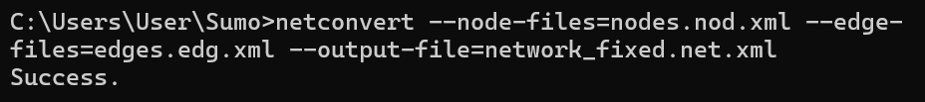

You can also verify its creation using folders as seen below:

**Final thing is to check all the folders in your sumo directory are exactly as these ones:**

If there’s any issues upto here please circle back through the previous steps or contact me !

--------------------------------------------------------------------------------------------------------------

**STEP 6:**  
**Running the simulation**

Once all other steps are completed and files are verified – navigate back to your sumo directory using command prompt!

Run the following commands within the prompt to run the simulation in either Debug or normal mode (Depending on requirements)

**sumo-gui -c simulation.sumocfg --verbose true** – DEBUG Mode

**sumo-gui -c simulation.sumocfg –** Normal Mode

**BEFORE PRESSING THE PLAY BUTTON PLEASE:**  
Change the delay in sumo to be: 150 and scale of traffic to 2!

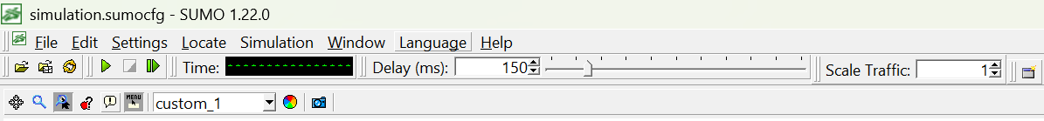This can be done using the GUI at the top!

**AT THIS POINT – THE SIMULATION SHOULD RUN & PROTOTYPE SETUP IS COMPLETE!**

**Lmk if there are any issues or questions before or during SETUP!!!**

**THE FILES FOR THE SIMULATION ARE STORED IN THE TEAMS DIRECTORY – but id recommend doing it manually so we all understand how to add new things and setup allowing you to build upon It more easily!**